HANDLES:
- Twitter: @RepPressley
- Facebook: @RepAyannaPressley
- Instagram: @RepAyannaPressley
HASHTAGS:
- #STRONGSupport
AMPLIFY:
Elevate our op-ed announcing the bill in STAT News on Twitter and Facebook.
TWEETSTORM:
On Thursday, October 22 at 4p.m. ET, take to Twitter to share a post in support of the #STRONGSupport for Children Act. Pair sample copy with a graphic.
SAMPLE COPY:
- .@RepPressley’s #STRONGSupport for Children Act would fund gender-responsive, culturally-specific, community-based approaches to addressing childhood trauma.
📞 Call your representative and tell them to sign on as a co-sponsor of H.R. 8544.
- COVID-19 has exposed our children to unprecedented levels of stress, illness, homelessness & financial insecurity. Policies should be informed by the experiences of those most impacted.

Thank you, @RepPressley for your leadership and for introducing the #STRONGSupport for Children Act.

- Police brutality, white supremacy & mass incarceration all affect the mental & physical health & wellbeing of our children -- especially BIPOC children -- resulting in trauma.
@RepPressley’s #STRONGSupport for Children Act gets at the root of the problem.
- 2/3 children experience at least one seriously traumatic event by age 16.
Children of color are 2X more likely to have these experiences than white children.
@RepPressley’s #STRONGSupport for Children Act is a long overdue step toward trauma-informed policymaking. [link]

GRAPHIC:
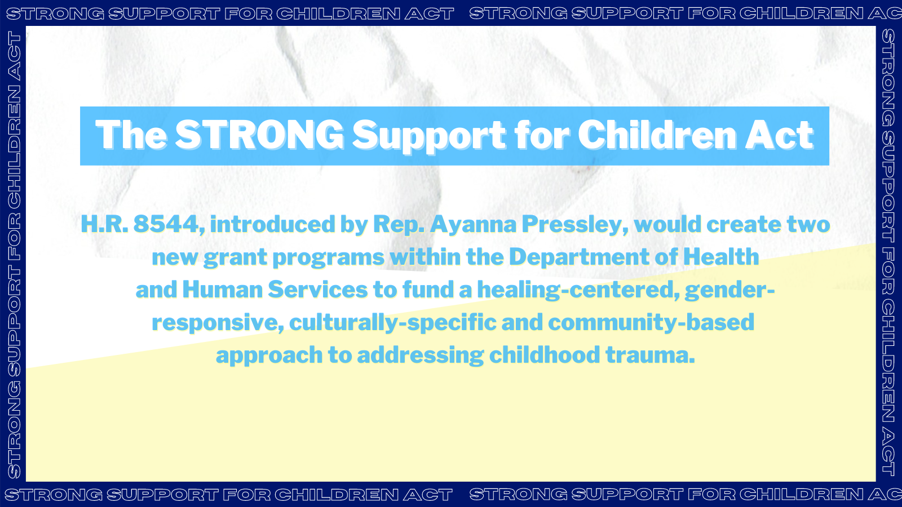
→ DOWNLOAD
+ ADDITIONAL GRAPHICS:
- Twitter
- Instagram/Facebook

